Dear Sirs:
First of all, many thanks for visiting us in Taipei autumn electronics exhibition and very glad to have initial contact with you.
We have been handling in the electronic field since 1995 and have become one of professional manufacturer and the leading suppliers of various computer components. For example. Connectors: Pin header, Female header, Box header, Box header with lock, Housing, Wafer, IDC/FD, D-SUB, USB/DIN, PLCC socket, IC socket, MINIJUMP/board to board… By keeping our principle of EXCELLENT QUALITY, COMPETITIVE PRICES, GOOD SERVICE.
By this opportunity, we hope to set up our business relationship with you. Please do not hesitate to specify articles, which interest you and just send us your enquiry with your specified drawing or specs. You will certainly enjoy the best cooperation with us. We are also welcome OEM/ODM, we convince that we can manufacture more and more new items by our hard work and progress.
Thank you very much for your attention to the above and looking forward to hearing from you very soon.

Best Regards.
Anely

philemon electronic co., LTD is the Tung Kuan branch of huey-chyuan technology co., LTD.
http： www.dgphilemon.cn.alibaba.com
email: philimon886@yahoo.com.cn anelylqq@126.com
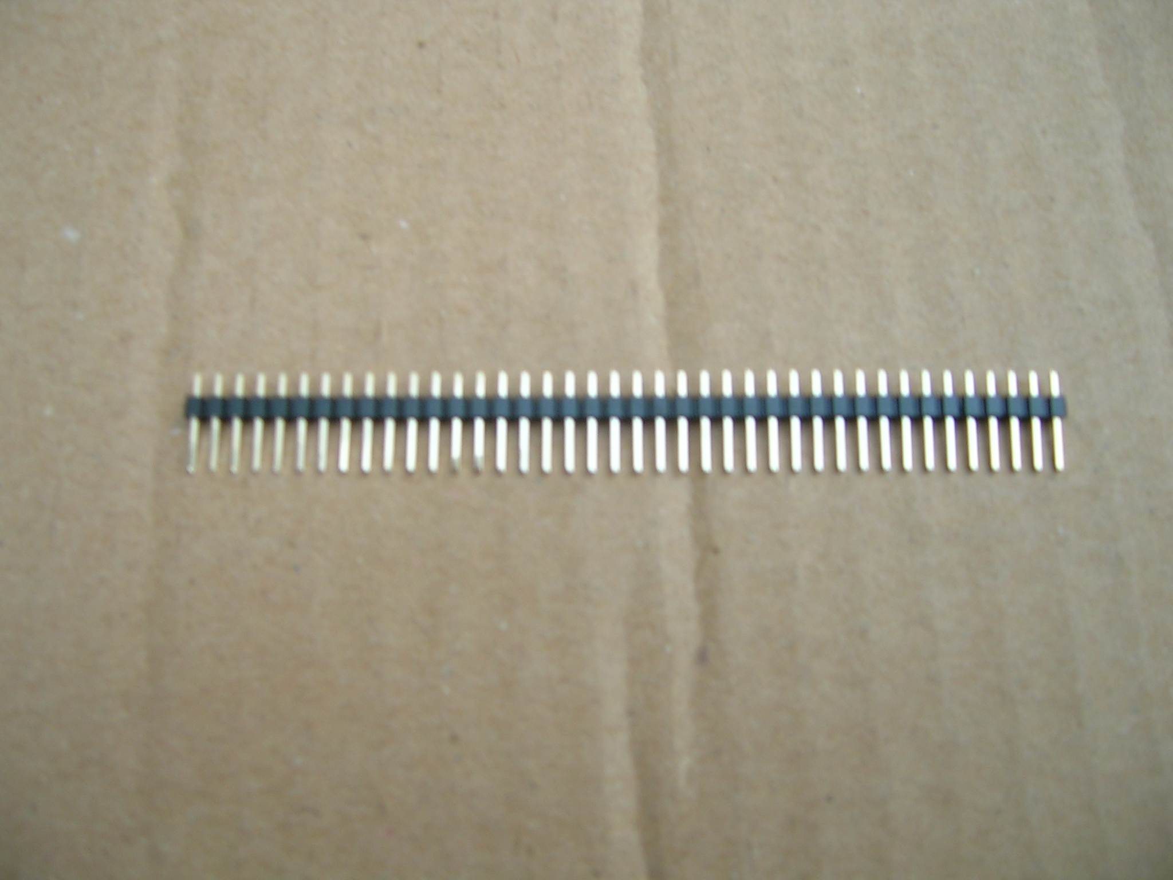
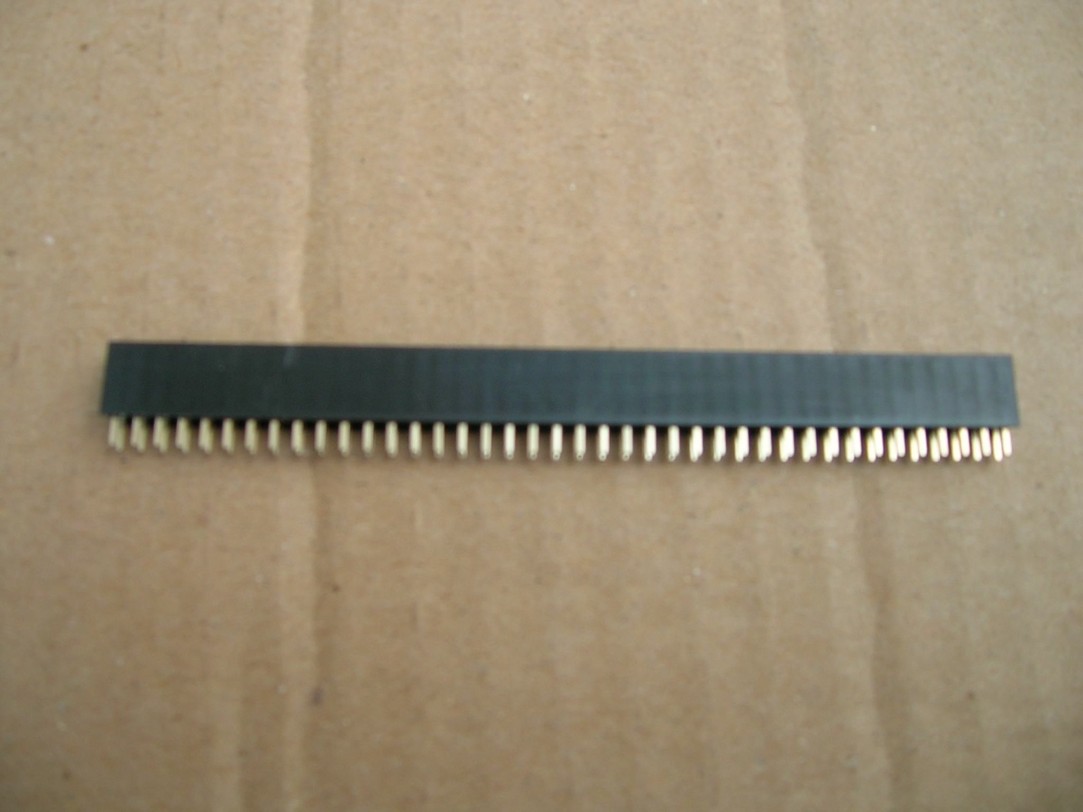

Female header 1X40P USD: 160.00/Kpcs Pin header 1X40P USD: 42.70/Kpcs
2X40P USD: 309.33/Kpcs 2X40P USD: 85.33/Kpcs

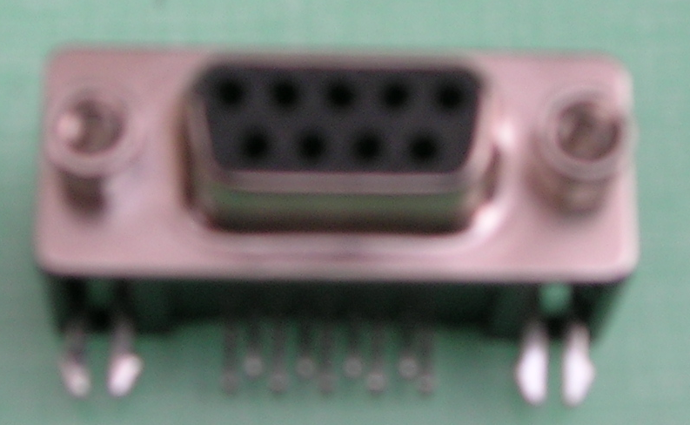
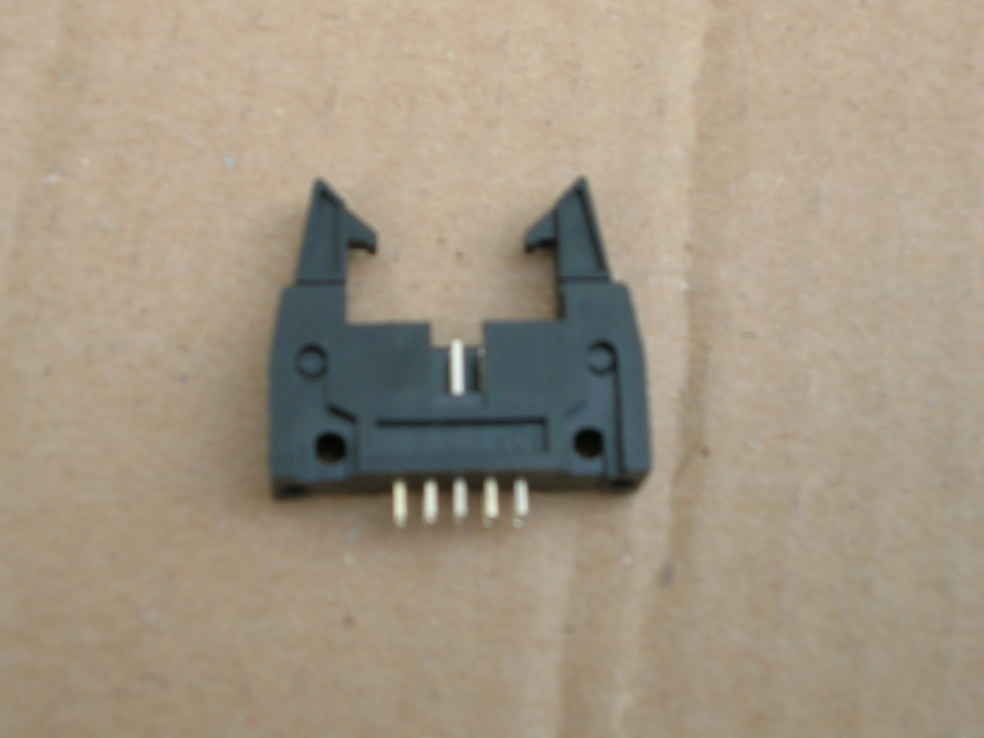
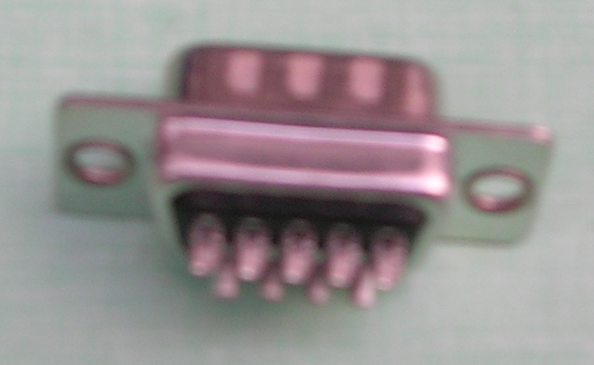
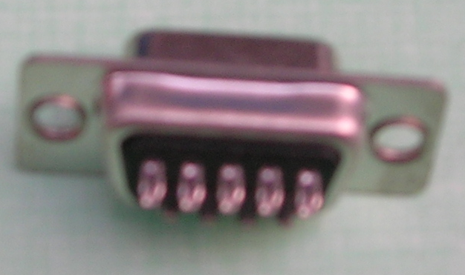

Box header with lock D-SUB for DB D-SUB for DB D-SUB for DR
For 10P BK 9M 9F 9M or 9F
USD: 66.67/Kpcs USD: 53.33/Kpcs USD: 56/Kpcs USD: 100.00/Kpcs

