
ST

HANDOUK

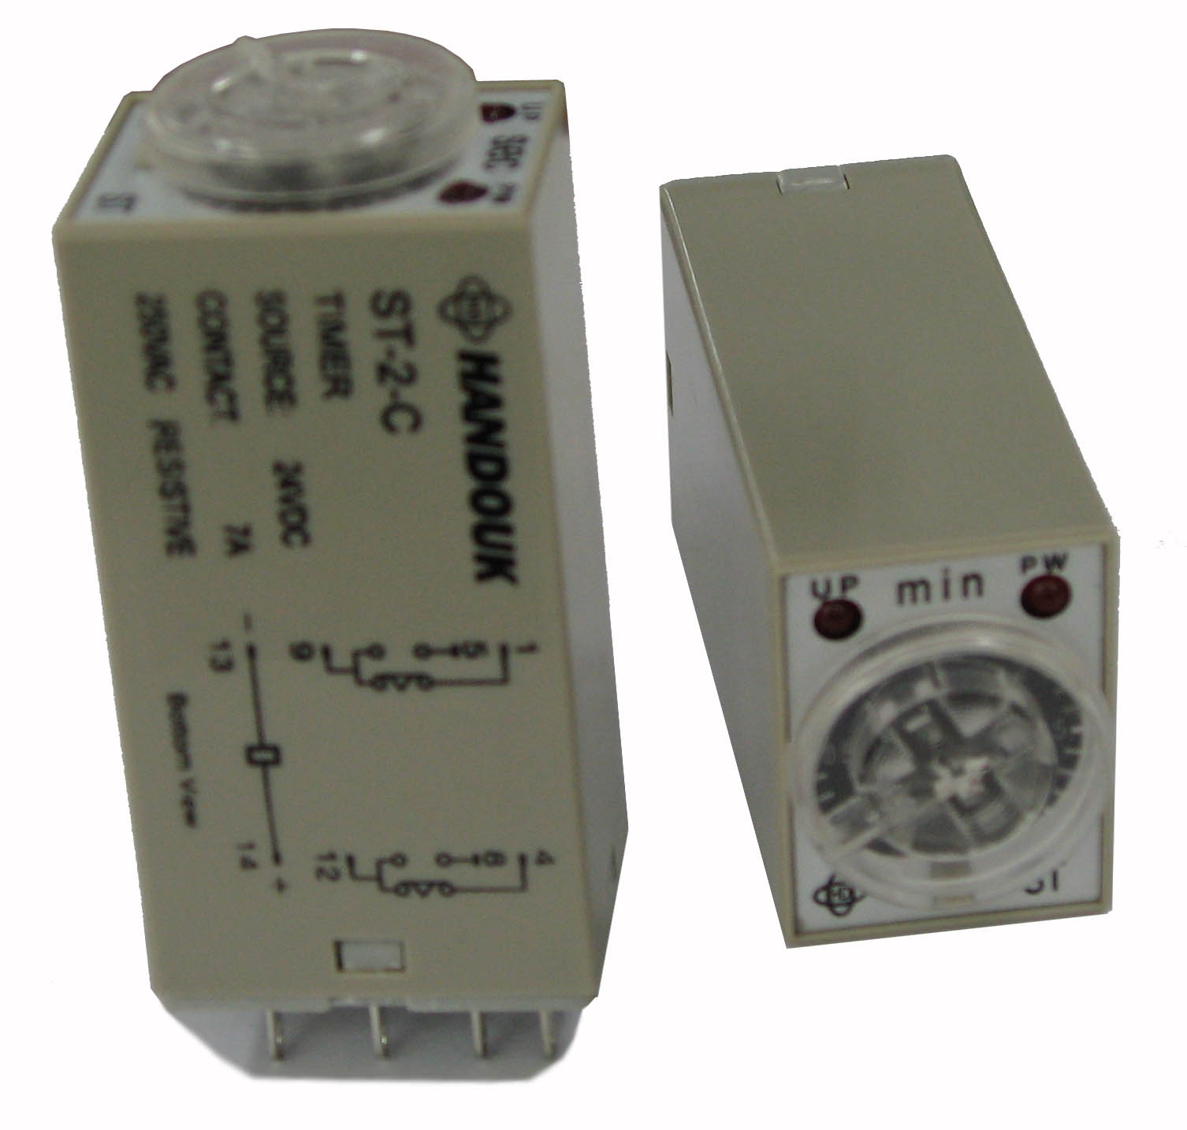
►FEATURES
►CHARACTERISTICS
● Semi-multi power supply voltage
● Exclusive C-MOS IC permits miniaturization and assures high performance
● High repeat accuracy : ±5% including the initial value
● Short resetting time : 0.1 second max. including the time
when the timer resets in operation
● Large transparent time setting knob facilitates time setting
● Equipped with a LED power-ON indicator
● Environmental friendly product (RoHs compliant)
● Outline Dimensions: 28.0 x 21.5 x 52.0mm
Accuracy of operating time(Max) |  | ±5%
Setting error (Max.)¹⁾ |  | ±10%±50ms
Reset time (Max.) |  | 0.1ms(Including halfway reset
Reset voltage (Max.) |  | 10% of rated supply voltage
Influence of Voltage (Max.)¹⁾ |  | ±2%
Influence of temperature (Max.)¹⁾ |  | ±2%
Insulation resistance (Min.) |  | 100M ohm (at 500VDC)
Dielectric  Strength  Between | contacts | 1,500VAC 1min
Dielectric  Strength  Between | circuits | 1,500VAC 1min
Dielectric  Strength  Between | contact sets | 1,000VAC 1min
Vibration resistance | Destruction | 10 to 55Hz, 0.75mm single amplitude
Vibration resistance | Malfunction | 10 to 55Hz, 0.50mm single amplitude
Shock resistance | Destruction | 1,000 m/s² (100g)
Shock resistance | Malfunction | 100 m/s² (10g)
Ambient temperature | Operating | -10°C to 50°C (with no icing)
Ambient temperature | Storage | -25°C to 65°C (with no icing)
Ambient humidity |  | 35% to 85% RH
Malchanical life (Min) |  | 1x10⁷ ops (under no load at 1,800 ops/h)
Electrical life (Min.) |  | ST-2 : 1x10⁵ ops (7A 250VAC/30VDC. Res. load)  ST-4 : 1x10⁵ ops (5A 250VAC/30VDC. Res. load)
Enclosure rating |  | IP40
Weight |  | 50g
Notes: 1) Add ±10ms to above value for the 1s range model

►TIME RANGE
Code | Rated time | Time setting range | Code | Rated time | Time setting range
A | 1 s | 0.1 to 1 s | G | 5 min | 0.2 to 5 min
B | 5 s | 0.2 to 5 s | H | 10 min | 0.5 to 10 min
C | 10 s | 0.5 to 10 s | I | 30 min | 1 to 30 min
D | 30 s | 1.0 to 30 s | J | 60 min | 2 to 60 min
E | 60 s | 2.0 to 60 s | K | 3 h | 0.1 to 3 h
►ORDERING INFORMATION
 | ST-2 | A | 24VDC | XXX
Type | ST-2 : 7A 250VAC/30VDC, 2pole  ST-4 : 5A 250VAC/30VDC, 4pole
Timing range | A to L (Show in the timing range table)
Control voltages | 12, 24, 48VDC, 110, 220, 240VAC
Customer special code | Only for special requirements

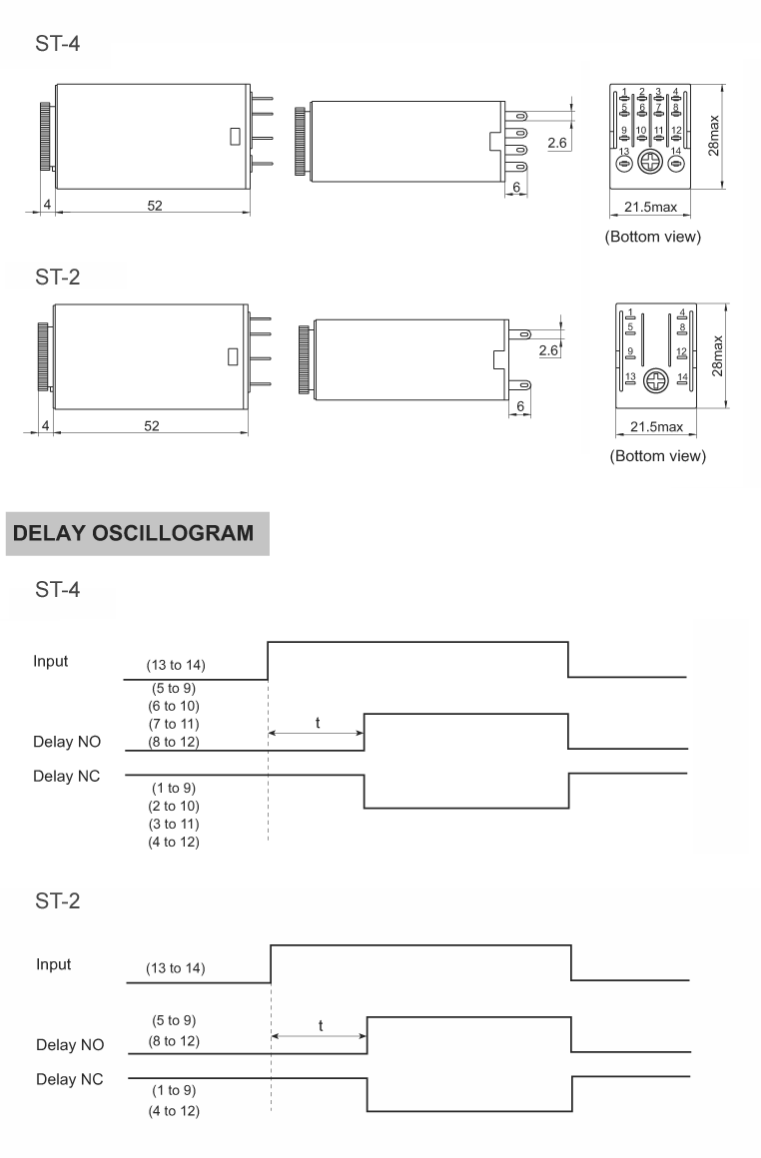
►OUTLINE DEMENSIONS

