
SJ

HANDOUK

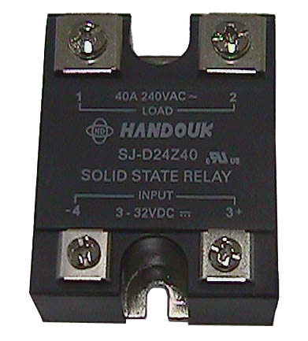
►FEATURES
● 4000V dielectric strength  ● Photo isolation  ● Built-in snubber  ● Zero cross or random turn-on  ● TRIAC AC output  ● Panel mount  ● DC or AC control | ● With LED indicator or not  ● Environmental protection product  available (RoHs compliant)  ● Size (LxWxH) : 58.4 x 45.7 x 22.9mm  ● E197546

►description
The SJ offer 3-32VDC, 110VAC, or 220VAC input control, with outputs rated at 10,15,20,25 or 40Amps.
All models include an internal snubber. The relays provide 4000Vrms optoisolation, between input and output. Outline dimension is 58.4 x 45.7 x 22.9mm.
►INPUT
Control voltage range (DC input) | 3 to 32VDC
Control voltage range (AC input) | 85 to 132VAC (110V input)  175 to 264VAC (220V input)
Must operate voltage (DC input) | Max. 3 VDC
Must operate voltage (AC input) | 85VAC (110V input)  175VAC (220V input)
Must release voltage (DC input) | Min. 1.0VDC
Must release voltage (AC input) | 10VAC
Maximum input current (DC input) | 25mA (at 32VDC)
Maximum reverse protection voltage (DC input) | -32VDC
►OUTPUT
Type (SJ- D□□□) | D□□10 | D□□15 | D□□20 | D□□25 | D□□40
Load Voltage  range(at 47-63HZ) | D240 48 to 280Vrms
Load Voltage  range(at 47-63HZ) | D380 48 to 400Vrms
Transient  over voltage | D240 600Vpk
Transient  over voltage | D380 800Vpk
Load current range(A) | 0.1 to 10 | 0.1 to 15 | 0.1 to 20 | 0.1 to 25 | 0.1 to 40
Max. surge current(10ms) | 100Vpk | 150Vpk | 200Vpk | 250Vpk | 400Vpk
Max. leakage current | 5mA | 5mA | 5mA | 5mA | 5mA
Max. on-state voltage drop | 1.5VAC
Max. turn-on time | 1/2 cycle + 1ms (Zero cross)
Max. turn-on time | 1ms (Random turn-on)
Max. turn-on time | 1/2 cycle + 1ms
Min. off-state(dv/dt) | 200V / µS
Min. power factor | 0.5
►GENERAL
Type (SJ- D□□□) |  | D□□10 | D□□15 | D□□20 | D□□25 | D□□40
Dielectric strength  ( input to output ) |  | 4000VAC (50/60 Hz, 1 min.)
Insulation resistance |  | 1000MΩ (50/60 Hz, 1 min.)
Ambient temperature | Operating | -30°C to +80°C
Ambient temperature | Storage | -30°C to +100°C
Unit weight |  | Typically 88g
►ORDERING INFORMATION
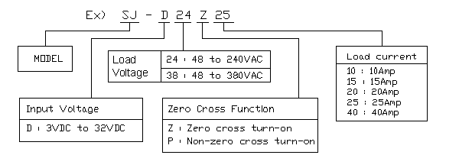
►Precautions
- When choosing a SSR, please notice the actual load current and working ambient
temperature. To use the SSR correctly, please refer to CHARACTERISTICS DATA
and make sure the heat sink size when it works in full load current.
- Apply heat-radiation silicon grease of heat conductive sheet between the SSR and heat sink. There will be a space between the SSR and heat sink Attached to the SSR. Therefore, the generated heat of the SSR cannot be radiated properly without the grease. As a result, the SSR may be overheated and damaged or deteriorated.
- Tighten the SSR terminal screws properly. If the screws are not tight, the SSR will be damaged by heat generated when the power in ON. Perform wiring using the tightening torque shown in the following table.
Screw size | Recommended tightened torque
M3 | 0.58 to 0.98 N·m
M4 | 0.98 to 1.37 N·m

►dimensions (Unit: mm)
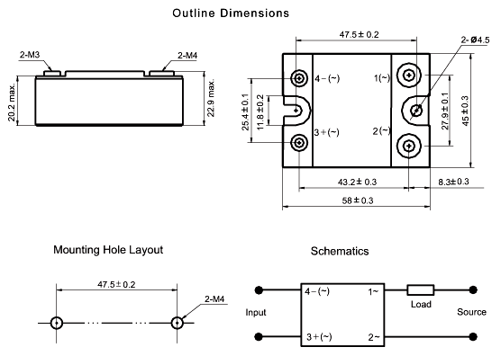

►CHARACTERISTICS CURVE
