
HL1

HANDOUK

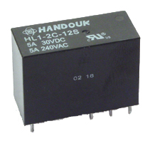
►FEATURES

● 1 Form A, I Form C, 2 Form A,
2 Form C configurations.
● 5A, 10A, 16A contact ratings.
● Sealed types.

Size (L x W x H)
29 x 12.7 x 20mm

►CONTACT DATA
Contact Form |  | 1C (10A) | 1CH (16A) | 1CT (16A) | 2C (5A) | 2CM (8A)
Contact Ratings |  | 10A  250VAC  30VDC | 16A  250VAC  30VDC | 16A  250VAC  30VDC | 5A  250VAC  30VDC | 8A  250VAC  30VDC
Contact Material |  | Ag alloy
Max. Switching Voltage |  | 250VAC / 30VDC
Max. Switching Current |  | 12A | 20A | 20A | 8A | 8A
Max. Switching Power |  | 2500VA/300W
Contact Resistance |  | 100mΩ at 6VDC 1A
Life Expectancy | Electrical | 100,000 Operations (at 30 ops a minute)
Life Expectancy | Mechanical | 10,000,000 Operations
►OPERATION CONDITION
Insulation Resistance |  |  | 100MΩ min (at 500VDC)
Dielectric Strangth | Between open Contacts |  | 1,000VAC (For one minute)
Dielectric Strangth | Between coil & Contacts |  | 5,000VAC (For one minute)
Operate time |  |  | 20ms
Release Time |  |  | 10ms
Shock resistance | Operating Extremes |  | 10G
Shock resistance | Damage Limits |  | 100G
Vibration resistance |  |  | 10~55Hz Double amplitude
Humidity |  |  | 40~85%
Temperature Range |  |  | -30 ~ 70℃(-40~158°F)
Weight |  |  | Approx 14g
Safety Standard |  | UL | E197546
 |  | TUV | R50056430

►COIL PARAMETER
Nominal  Voltage  (VDC) | Coil Resistance at 20 C (Ω) |  | Max  Operate Voltage | Min.  Release  Voltage | Max.  Applicable  Voltage
Nominal  Voltage  (VDC) | 0.54W | 0.72W | Max  Operate Voltage | Min.  Release  Voltage | Max.  Applicable  Voltage
3 | 17 | 13 | 2.4 | 0.15 | 3.9
5 | 46 | 35 | 4 | 0.25 | 6.5
6 | 67 | 50 | 4.8 | 0.3 | 7.8
9 | 150 | 110 | 7.2 | 0.45 | 11.7
12 | 270 | 200 | 9.6 | 0.6 | 15.6
24 | 1050 | 800 | 19.2 | 1.2 | 31.2
48 | 4,250±15% | 3,200 | 38.4 | 2.4 | 62.4
60 | 6,800 ±15% |  | 48 | 3.0 | 78
100 | 18,8600±15% |  | 80 | 5.0 | 130

►ORDERING INFORMATION
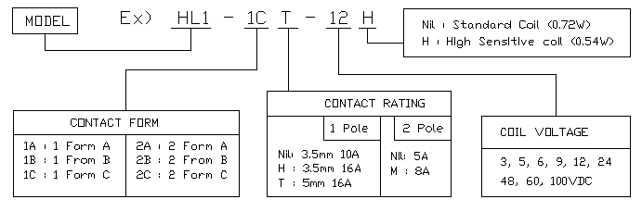

►DIMENSIONS (Unit: MM)
HL1-1C
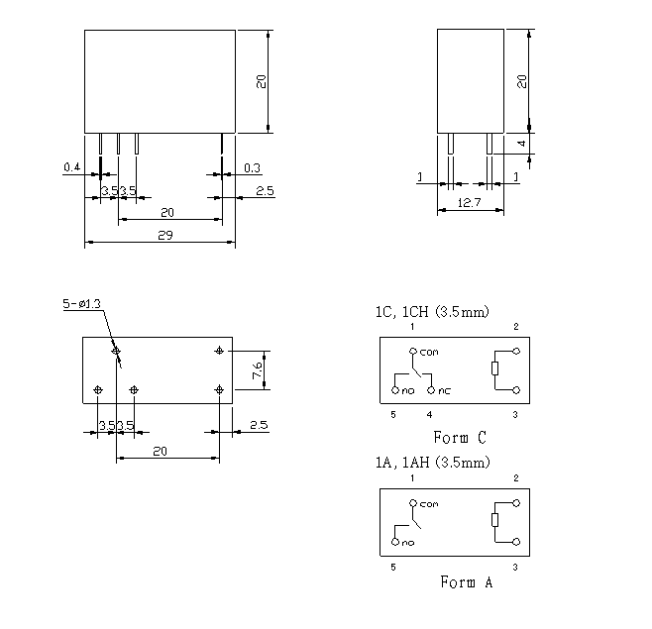

HL1-1CT
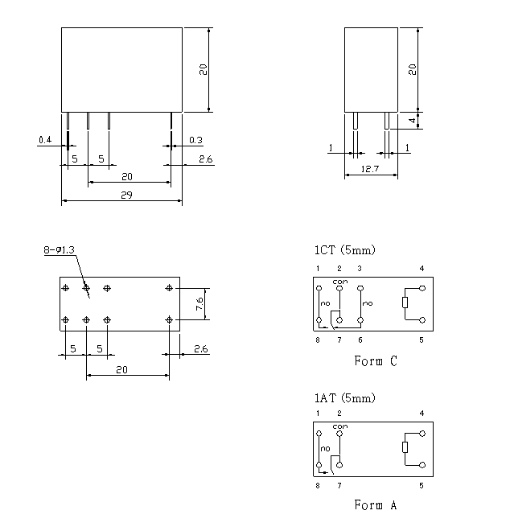

HL1-2C
