
HA1

HANDOUK
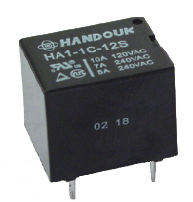
■ FEATURES
● 7A, 10A Switching capability.
● Subminiature.
● Standard PC Layout.

■ CONTACT DATA
Contact Form |  | 1A | 1C
Contact Material |  | Ag Alloy | AgSnO²
Contact Ratings |  | 10A 240VAC  12A 120VAC / 24VDC | 7A 240VAC  10A 120VAC / 24VDC
Max Switching Voltage |  | 250VAC / 30VDC
Max Switching Current |  | 15A
Max Switching Power |  | 2,770VA / 240W
Contact Resistance |  | 100mΩ Max at 6VDC 1A
Life Expectancy | Electrical | 100,000operations at 30operations/minute)
Life Expectancy | Mechanical | 10,000,000operations

■ GENERAL DATA
Insulation Resistance |  | 100M Ω Min. at 500VDC
Dielectric  Strength | Open Contacts | 750VAC (For one minute)
Dielectric  Strength | Contacts and Coil | 1,500VAC (For one minute)
Operate Time |  | 10ms
Release Time |  | 5ms
Temperature Range |  | -40℃ ~ 70℃
Shock  Resistance | Operate Extremes | 10G
Shock  Resistance | Damage Limits | 100G
Vibration Resistance |  | 10 ~ 50Hz 1.5mm
Humidity |  | 40 ~ 85%
Weight |  | Approx 10g
Safety Standard |  | TUV R50054834
 |  | UL197546

■ COIL DATA
Nominal Voltage  (VDC) | Coil Resistance  At 20 ±10% Ω |  | Max Operating  Voltage  VDC | Min Release  Voltage  VDC | Max Applicable  Voltage  VDC
Nominal Voltage  (VDC) | 0.36W | 0.45W | Max Operating  Voltage  VDC | Min Release  Voltage  VDC | Max Applicable  Voltage  VDC
3 | 25 Ω |  | 2.25 | 0.3 | 3.9
5 | 70 Ω |  | 3.75 | 0.5 | 6.5
6 | 100 Ω |  | 4.5 | 0.6 | 7.8
9 | 225 Ω |  | 6.75 | 0.9 | 11.7
12 | 400 Ω |  | 9 | 1.2 | 15.6
18 | 900 Ω |  | 13.5 | 1.8 | 23.4
24 | 1,600 Ω |  | 18 | 2.4 | 31.2
48 | 6,400 Ω±15% | 5,100 Ω±15% | 36 | 4.8 | 62.4

■ ORDERING INFORMATION
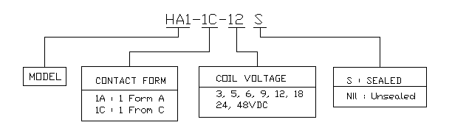
■ OVERALL AND MOUNTING DIMENSIONS
