
BC2

HANDOUK

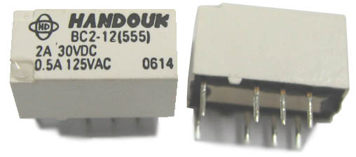
■ FEATURES
* High dielectric withstand of 2,000VAC (Between coil and contacts)
* High contact capacity:2A 30VDC
* Surge withstand voltage up to 2,500VAC (Between coil and contacts)
* SMT type available
* Bifurcated contacts
* Single side stable and & latching type available
■ CONTACT DATA
Contact Arrangement |  | DPDT (2 Form C)
Initial Contact Resistance |  | 50m ohm (Max)
Contact Material |  | AgNi + Au plated
Rated load (Res. Load) |  | 2A 30VDC, 0.5A 125VAC
Max. switching power |  | 60W, 62.5VA
Max. switching Voltage |  | 220VDC, 250VAC
Max. switching current |  | 2A
Min. Applicable Load |  | 10mV 10 micro A
Life  Expectancy | Electrical | 1 x 10⁵ ops (2A 30VDC)  5 x 10⁵ ops (1A 30VDC)  1 x 10⁵ ops (0.5A 125VAC)
Life  Expectancy | Mechanical | 1 x 10⁸ ops (at 0.5A 125VAC

■ GENERAL DATA
Initial Insulation resistance |  |  |  | 1000M ohm 500VDC
Dielectric  Strength  between | Coil and contacts |  |  | 2,000VAC 1min.
Dielectric  Strength  between | Open contacts |  |  | 1,000VAC 1min.
Dielectric  Strength  between | Contact sets |  |  | 1,500Vrms, 1min
Surge withstand voltage |  |  |  | Between open contacts(10x160µs) :1,500VAC (FCC part 68)  Between coil and contacts(2x10µs) : 2,500VAC (Bellcore)
Operate time (nominal voltage) |  |  |  | Max. 4ms
Release time (nominal voltage) |  |  |  | Max. 4ms
Ambient temperature |  |  |  | -40°C~+85°C
Humidity |  |  |  | 35% to 85% R.H.
Vibration  resistance |  |  | Functional | 10 to 55Hz 3.3mm DA
 |  |  | Destructive | 10 to 55Hz 5mm DA
Shock  resistance |  | Functional |  | 750m/s²(75g)
 |  | Destructive |  | 1,000m/s²(100g)
Termination |  |  |  | DIP, SMT
Unit weight |  |  |  | Approx. 2g
Construction |  |  |  | Sealed IP67
■ COIL
Coil power | Single side stable | 140mW
Coil power | Latching 1 coil | 100mW
Coil power | Latching 2 coil | 200mW
Temperature Rise |  | Max. 50°C
Coil Voltage |  | See coil data table

■ SAFETY APPROVAL RATING

UL&CUR | 2A 30VDC  0.5A 125VAC
■ COIL DATA
Single side stable standard(140mW) 20°C
Norminal  Voltage  (VDC) | Norminal  current  (mA) | Pick-up  voltage  VDC (Max.) | Drop-out  voltag  VDC (Min.) | Coil  resistance  Ω (10%) | Nominal  Power  (mW) | allowable  Voltage  VDC(Max.)
1.5 | 93.8 | 1.13 | 0.15 | 16 | 140 | 2.2
3 | 46.7 | 2.25 | 0.3 | 64.3 | 140 | 4.5
4.5 | 31 | 3.38 | 0.45 | 145 | 140 | 6.7
5 | 28.1 | 3.75 | 0.5 | 178 | 140 | 7.5
6 | 23.3 | 4.5 | 0.6 | 257 | 140 | 9
9 | 15.5 | 6.75 | 0.9 | 579 | 140 | 13.5
12 | 11.7 | 9 | 1.2 | 1,028 | 140 | 18
24 | 5.8 | 18 | 2.4 | 4,114 | 140 | 36
48 | 5.6 | 36 | 4.8 | 8,533 | 270 | 57.6

Latching (1 coil) standard(100mW) 20°C
Norminal  Voltage  (VDC) | Norminal  current  (mA) | Set/Reset  voltage  VDC (Max.) | Coil  resistance  Ω (10%) | Nominal  Power  (mW) | allowable  Voltage  VDC(Max.)
1.5-L1 | 66.7 | 1.13 | 22.5 | 100 | 2.7
3-L1 | 33.3 | 2.25 | 90 | 100 | 5.4
4.5-L1 | 22.2 | 3.38 | 203 | 100 | 8.1
5-L1 | 20 | 3.75 | 250 | 100 | 9
6-L1 | 16.7 | 4.5 | 360 | 100 | 10.8
9-L1 | 11.1 | 6.75 | 810 | 100 | 16.2
12-L1 | 8.3 | 9 | 1,440 | 100 | 21.6
24-L1 | 4.2 | 18 | 5,760 | 100 | 43.2

Latching (2 coil) standard(200mW) 20°C
Norminal  Voltage  (VDC) | Norminal  current  (mA) | Set/Reset  voltage  VDC (Max.) | Coil  resistance  Ω (10%) | Nominal  Power  (mW) | allowable  Voltage  VDC(Max.)
1.5-L2 | 133.9 | 1.13 | 11.2 | 200 | 2.7
3-L2 | 66.7 | 2.25 | 45 | 200 | 5.4
4.5-L2 | 44.5 | 3.38 | 101 | 200 | 6.7
5-L2 | 40 | 3.75 | 125 | 200 | 7.5
6-L2 | 33.3 | 4.5 | 180 | 200 | 9.0
9-L2 | 22.2 | 6.75 | 405 | 200 | 13.5
12-L2 | 16.7 | 9 | 720 | 200 | 18
24-L2 | 8.3 | 18 | 2,880 | 200 | 36

■ ORDERING INFORMATION
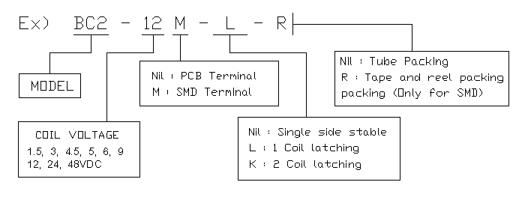
■ CHARACTERISTICS CURVE
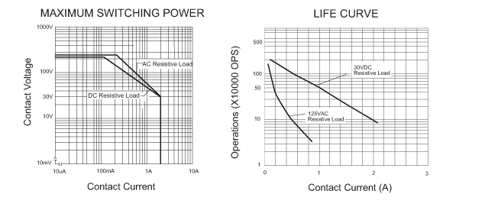

■ OVERALL AND MOUNTING DIMENSIONS
