BA1


HANDOUK
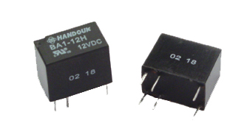
►FEATURES

- Most small size, Low Cost
- SPDT configurations
- PCB mounting, DIP package
►CONTACT DATA
Contact Arrangement | 1 C（1 Form C）
Contact Material | Ag + Au
Contact Rating (resistive) | 0.5A 125VAC, 1A 24VDC
Max Switching Voltage | 125VAC / 60VDC
Max Switching Current | 1A
Max Switching Power | 62.5VA / 30W
Contact Resistance | 100mΩ Max at 6VDC 1A
Life Expectancy Electrical | 100,000 Operations ( at30 Operations / minute)
►GENERAL DATA
Resistance |  |  | 100MΩ Min. at 500VDC
Dielectric Strength |  | Open Contacts | 400VAC (for one minute)
 |  | Contacts and coil | 1000VAC (for one minute)
Operate Time |  |  | 5ms Max
Release Time |  |  | 5ms Max
Temperature Range |  |  | -30°C ~ +70°C
Shock Resistance | Operating Extremes |  | 10G
Shock Resistance | Damage Limits |  | 100G
Vibration Resistance |  |  | 10-55Hz Double amplitude of 2.0mm
Humidity |  |  | 35%-85%RH
Weight |  |  | Approx 2.2g
Safety Standard |  |  | UL E197546

►COIL DATA
Coil voltage  (VDC) | Coil Resistance at 20°C |  |  | Pick-up Voltage  Max |  |  | Drop-out Voltage  Min | Applicable  Voltage  Max
Coil voltage  (VDC) | 0.36W | 0.2W | 0.15W | 0.36W | 0.2W | 0.15W | Drop-out Voltage  Min | Applicable  Voltage  Max
3 | 25 | 45 | 60 | 2.1 | 2.25 | 2.4 | 0.3 | 3.9
5 | 69.4 | 125 | 167 | 3.5 | 3.75 | 4.0 | 0.5 | 6.5
6 | 100 | 180 | 240 | 4.2 | 4.5 | 4.8 | 0.6 | 7.8
9 | 225 | 405 | 540 | 6.3 | 6.75 | 7.2 | 0.9 | 11.7
12 | 400 | 720 | 960 | 8.4 | 9 | 9.6 | 1.2 | 15.6
24 | 1600 | 2880 | 3840 | 16.8 | 18 | 19.2 | 2.4 | 31.2
►ORDERING INFORMATION
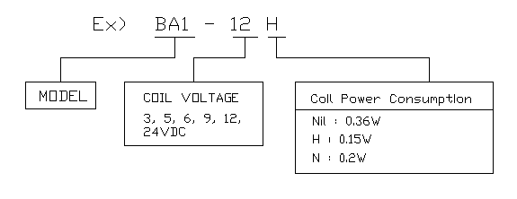

►DIMENSIONS (Unit: mm)
