 | Home > Products > Coils＆Inductors > PK | [ Back ]

PK
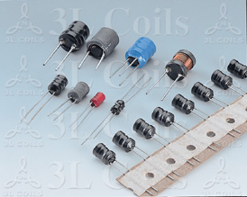
PEAKING COIL
Shape and size :
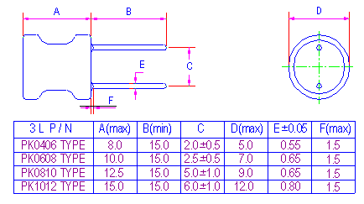
Features :
- Small size radial lead type .
- Small mounting space required .
- Excellent characteristics for High Q .
- Minimized distributed capacitance hence high SRF .
- Special lead wire construction prevents open circuit failures .
- Covered with PVC sleeve or UL tube .
- Can be taped for auto insertion .
Ordering information :
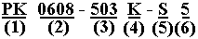
(1) Type : Peaking coils .
(2) Style : Core D=6 mm ; L=8 mm
(3)Inductance : Example : 503 is 50 mH
(4)Inductance tolerance :
J :5% ; K :10% ; M: 20% .
(5)PVC Sleeve or UL tube
(6)Sleeve color code .
Characteristics :
- Inductance range : 1.0uH to 100000uH .
- Current rating: Based on temperature rise not to exceed 20ºC .
- Operating temperature : -20ºC to 80ºC.
- Terminal strength : 0.5 Kg min .
- Test equipment :
For PK0406-1R0K to 102K, L tested by HP4342A Q Meter
For PK0406-122K to 253K, PK0608, PK0810 & PK1012, L tested by LCR meter @ 1KHz .
Q tested by HP 4342A Q meter .
DCR tested by Milliohm meter .
SRF tested by HM 9461 L-SRF meter .
Applications :
- TVs and Audio equipment .
- Telecommunication devices .
- Buzzers and Alarm systems .
- Switching Power Supplies.
- Systems requiring Band and High Q.
- Other noise filters .

