Coils & Inductors
 | Home > Products > Coils＆Inductors > EC | [ Back ]

EC
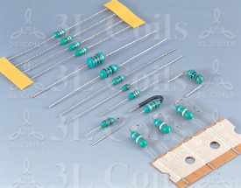
CONFORMAL COATED INDUCTOR
1.SHAPE AND SIZE :
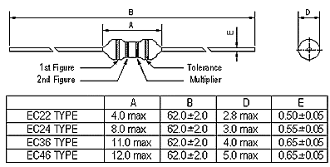
2. Features:
(1). Conformal coated inductors .
(2). Special magnetic core structure contributes to high Q and Self-Resonant Frequencies (S.R.F.).
(3). Epoxy coated for better reliability.
(4). Wide inductance range.
(5). Ideal for auto insertion.
3. Ordering information :
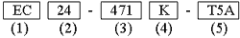
(1). Type: Epoxy Coated.
(2). Style: According to core size.
(3). Inductance: Example: "471" for 470 uH.
(4). Tolerance: "M" :+20% ; "K" :+10% ; "J" :+5% .
(5). Other information: "T5, T2, T5A, TF4, TF5, TF6" represents the Packing Mode. "U, F" represents the Shape.
4. Characteristics:
(1).Current Rating : Based on temperature
rise not to exceed 20ºC
(2).Operating temperature : -20ºC to 80ºC.
(3). Dielectric with standing voltage: 250 V r.m.s.
(4).Moisture & heat resist :
(5). Test equipment:
L & Q: HP 4285A precision Q meter.
DCR : Milli-ohm meter.
SRF : HM 9461 L-SRF meter.
5. Applications:
(1). OSC coils.
(2). TRAP coils.
(3). PEAKING coils.
Color Code Guide
EC24.EC36 & EC46 series are color band marked for identification. There are bands for these series indicating inductance value and tolerance. For valuse below 0.1uH, Gold indicates the decimal point while the next 3 bands show inductance value. There is no tolerance marked for values below 0.1uH.
The EC22 seris due to its size is only marked with 3 bands indicating inductance value with no decimal point and toleranve marked.
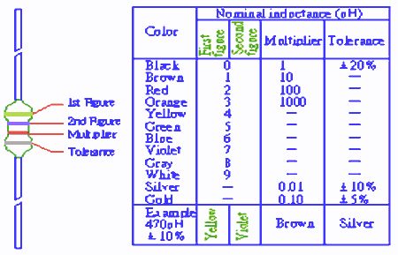

[ Back ]

